|  |  |  |  |  |
| --- | --- | --- | --- | --- |
| SL.NO | FIELD NAME | DATETYPE(SIZE) | KEY CONSTRAINTS | DESCRIPTION |
| 1 | cat_id | INT | PRIMARY KEY | Unique identifier for category |
| 2 | Name | VARCHAR (255) | NOT NULL | Name of the category |
| 3 | Desc | TEXT |  | Description of the category |

1.tbl_category

Primary key:cat_id

2.tbl_subcategory

Primary key : sub_id

Foreign key : cat_id(reference tbl_category )

|  |  |  |  |  |
| --- | --- | --- | --- | --- |
| SL.NO | FIELD NAME | DATETYPE(SIZE) | KEY CONSTRAINTS | DESCRIPTION |
| 1 | sub_id | INT | PRIMARY KEY | Unique identifier for subcategory |
| 2 | Name | VARCHAR (255) | NOT NULL | Name of the subcategory |
| 3 | Desc | TEXT |  | Description of the subcategory |
| 4 | cat_id | INT | FOREIGN KEY | Refer to category table Id |

3.tbl_product

Primary key : prod_id

Foreign key : sub_id(reference tbl_subcategory )

|  |  |  |  |  |
| --- | --- | --- | --- | --- |
| SL.NO | FIELD NAME | DATETYPE(SIZE) | KEY CONSTRAINTS | DESCRIPTION |
| 1 | prod_id | INT | PRIMARY KEY | Unique identifier for product |
| 2 | Name | VARCHAR (255) | NOT NULL | Name of the product |
| 3 | Desc | TEXT |  | Description of the product |
| 4 | Price | DECIMAL(25) | NOT NULL | Price of the product |
| 5 | Woodtype | VARCHAR (255) |  | Type of wood used |
| 6 | Img | VARCHAR (100) |  | URL of the product |
| 7 | sub_id | INT | FOREIGN KEY | Refer to subcategory table Id |

4.tbl_usertype

Primary key : type_id

|  |  |  |  |  |
| --- | --- | --- | --- | --- |
| SL.NO | FIELD NAME | DATETYPE(SIZE) | KEY CONSTRAINTS | DESCRIPTION |
| 1 | type_id | INT | PRIMARY KEY | Unique identifier for usertype |
| 2 | Typename | VARCHAR (100) | NOT NULL | Name of the usertype |
| 3 | Desc | TEXT |  | Description of the usertype |

5.tbl_login

Primary key : login_id

Foreign key : type_id(reference tbl_usertype )

|  |  |  |  |  |
| --- | --- | --- | --- | --- |
| SL.NO | FIELD NAME | DATETYPE(SIZE) | KEY CONSTRAINTS | DESCRIPTION |
| 1 | login_id | INT | PRIMARY KEY | Unique identifier for login |
| 2 | Username | VARCHAR (100) | NOT NULL | Username of login |
| 3 | Password | VARCHAR (60) | NOT NULL | password |
| 4 | Type_id | INT | FOREIGN KEY | Refer to usertype table Id |

6.tbl_user

Primary key : user_id

Foreign key : login_id(reference tbl_login )

|  |  |  |  |  |
| --- | --- | --- | --- | --- |
| SL.NO | FIELD NAME | DATETYPE(SIZE) | KEY CONSTRAINTS | DESCRIPTION |
| 1 | User_id | INT | PRIMARY KEY | Unique identifier for user |
| 2 | Full name | VARCHAR(250) | NOT NULL | Fullname of user |
| 3 | phone | VARCHAR(159) | NOT NULL | Phone number of user |
| 4 | address | TEXT |  | Address of the user |
| 5 | email | VARCHAR(150) | NOT NULL | Email of the user |
| 6 | login_id | INT | FOREIGN KEY | Refer to login table Id |

7.tbl_cart

Primary key : cart_id

Foreign key : user_id(reference tbl_user ),payment_id(reference tbl_payment Id)

|  |  |  |  |  |
| --- | --- | --- | --- | --- |
| SL.NO | FIELD NAME | DATETYPE(SIZE) | KEY CONSTRAINTS | DESCRIPTION |
| 1 | cart_id | INT | PRIMARY KEY | Unique identifier for cart |
| 2 | user_id | INT | FOREIGN KEY | Refer to user table Id |
| 3 | prod_id | INT | FOREIGN KEY | Refer to product table Id |
| 4 | Quantity | INT | NOT NULL | Number of items in the cart |

8.tbl_order

Primary key : order_id

Foreign key : user_id(reference tbl_user ),payment_id(reference tbl_payment Id),prod_id (reference tbl_product Id)

|  |  |  |  |  |
| --- | --- | --- | --- | --- |
| SL.NO | FIELD NAME | DATETYPE(SIZE) | KEY CONSTRAINTS | DESCRIPTION |
| 1 | order_id | INT | PRIMARY KEY | Unique identifier for order |
| 2 | user_id | INT | FOREIGN KEY | Refer to user table Id |
| 3 | prod_id | INT | FOREIGN KEY | Refer to product table Id |
| 4 | payment_id | INT | FOREIGN KEY | Refer to payment table Id |
| 5 | orderdate | DATE | NOT NULL | Date of the order placed |
| 6 | status | VARCHAR(120) | NOT NULL | Status of the order |

9.tbl_payment

Primary key : payment_id

Foreign key : order_id(reference tbl_order )

|  |  |  |  |  |
| --- | --- | --- | --- | --- |
| SL.NO | FIELD NAME | DATETYPE(SIZE) | KEY CONSTRAINTS | DESCRIPTION |
| 1 | payment_id | INT | PRIMARY KEY | Unique identifier for payment |
| 2 | order_id | INT | FOREIGN KEY | Refer to order table Id |
| 3 | Amount | DECIMAL | NOT NULL | Amount paid |
| 4 | Paymentmethod | VARCHAR | NOT NULL | Method of payment |
| 5 | Payment status | VARCHAR | NOT NULL | Status of payment |

10.tbl_seller

Primary key : seller_id

Foreign key : login_id(reference tbl_login )

|  |  |  |  |  |
| --- | --- | --- | --- | --- |
| SL.NO | FIELD NAME | DATETYPE(SIZE) | KEY CONSTRAINTS | DESCRIPTION |
| 1 | seller_id | INT | PRIMARY KEY | Unique identifier for seller |
| 2 | phone | VARCHAR | NOT NULL | Phonenumber of seller |
| 3 | login_id | INT | FOREIGIN KEY | Refer to login table Id |

11.tbl_stock

Primary key : stock_id

Foreign key : product_id(reference tbl_product Id),seller_id (reference tbl_seller Id)

|  |  |  |  |  |
| --- | --- | --- | --- | --- |
| SL.NO | FIELD NAME | DATETYPE(SIZE) | KEY CONSTRAINTS | DESCRIPTION |
| 1 | stock­_id | INT | PRIMARY KEY | Unique identifier for seller |
| 2 | prod_id | INT | FOREIGN KEY | Refer to product table Id |
| 3 | Quantity | INT | NOT NULL | Number of items in stock |
| 4 | Restock Date | DATE |  | Date when stock was updated |
| 5 | seller_id | INT | FOREIGN KEY | Refer to seller table Id |

Class diagram

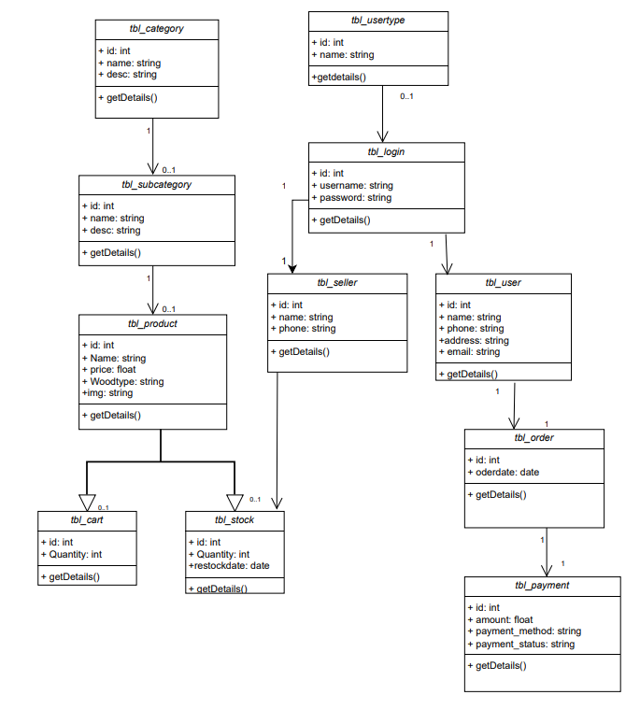

Object Diagram

Object diagram

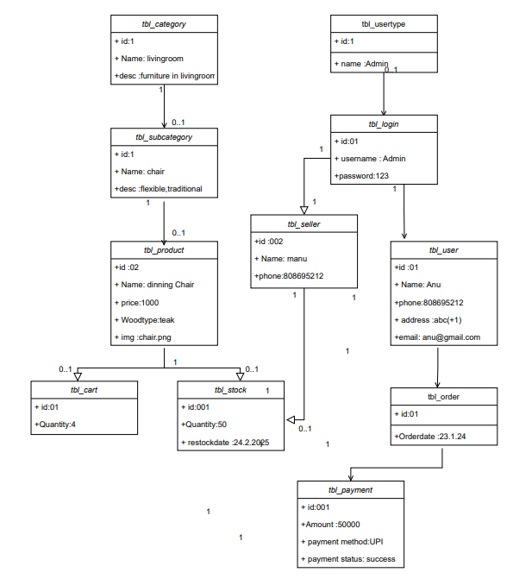

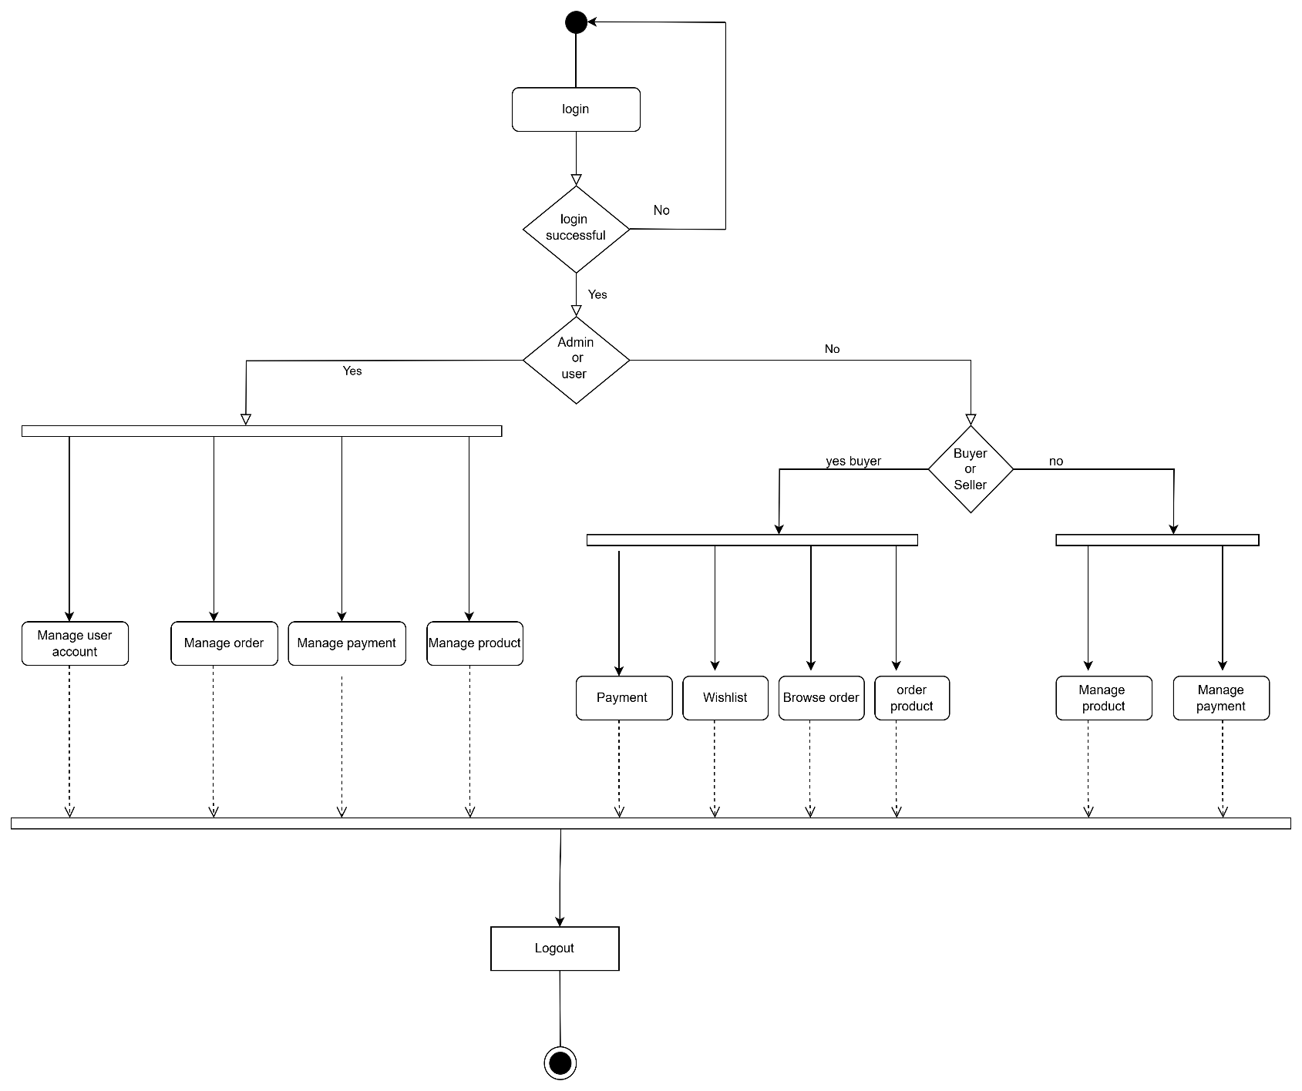Activity diagram

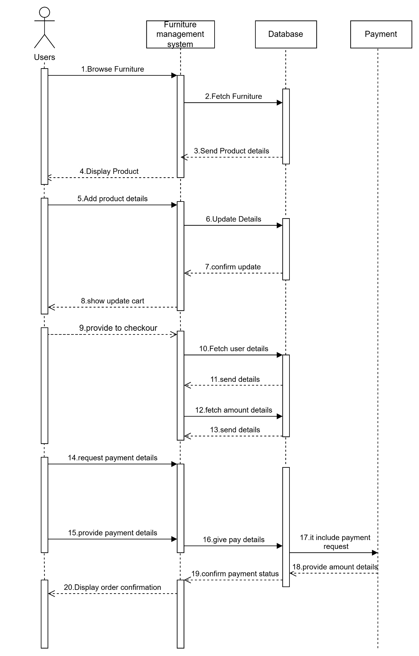Sequence diagram

State chart diagram

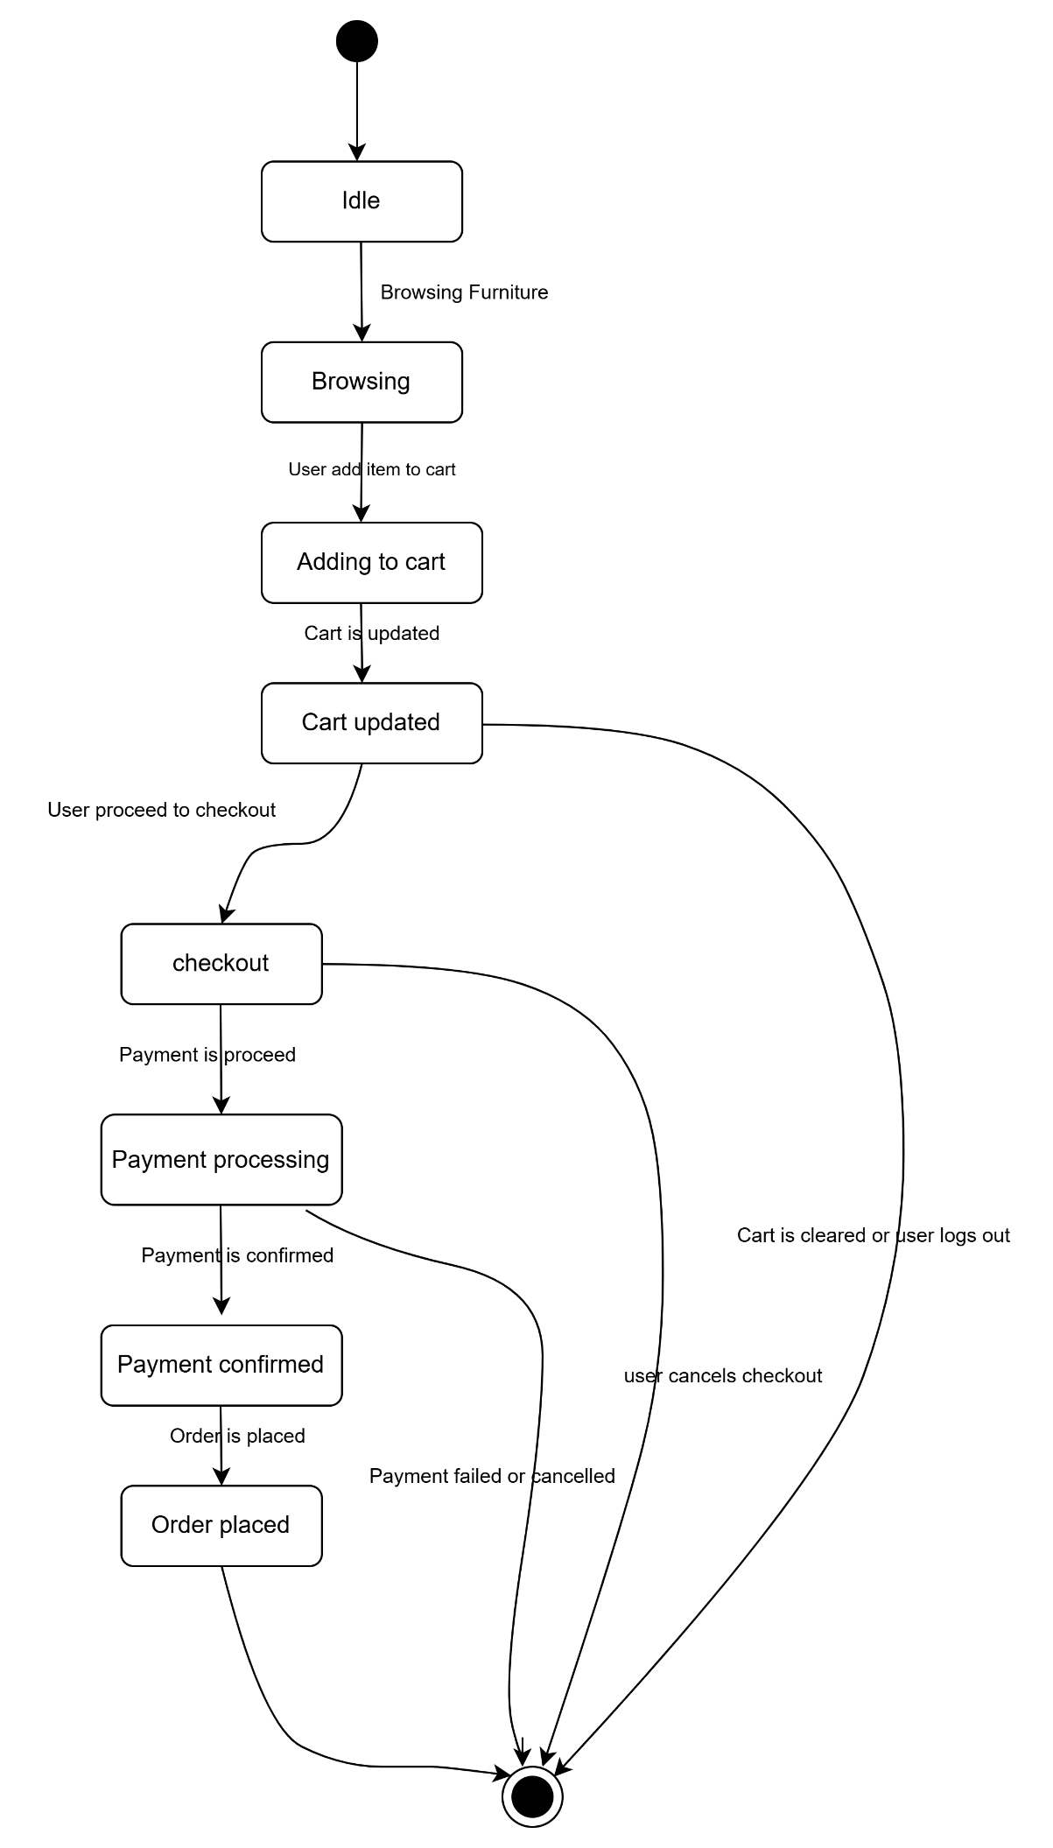

Deployment Diagram

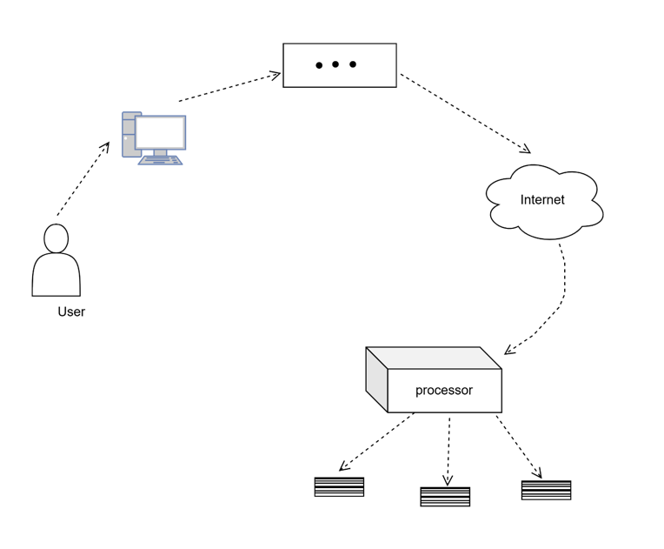

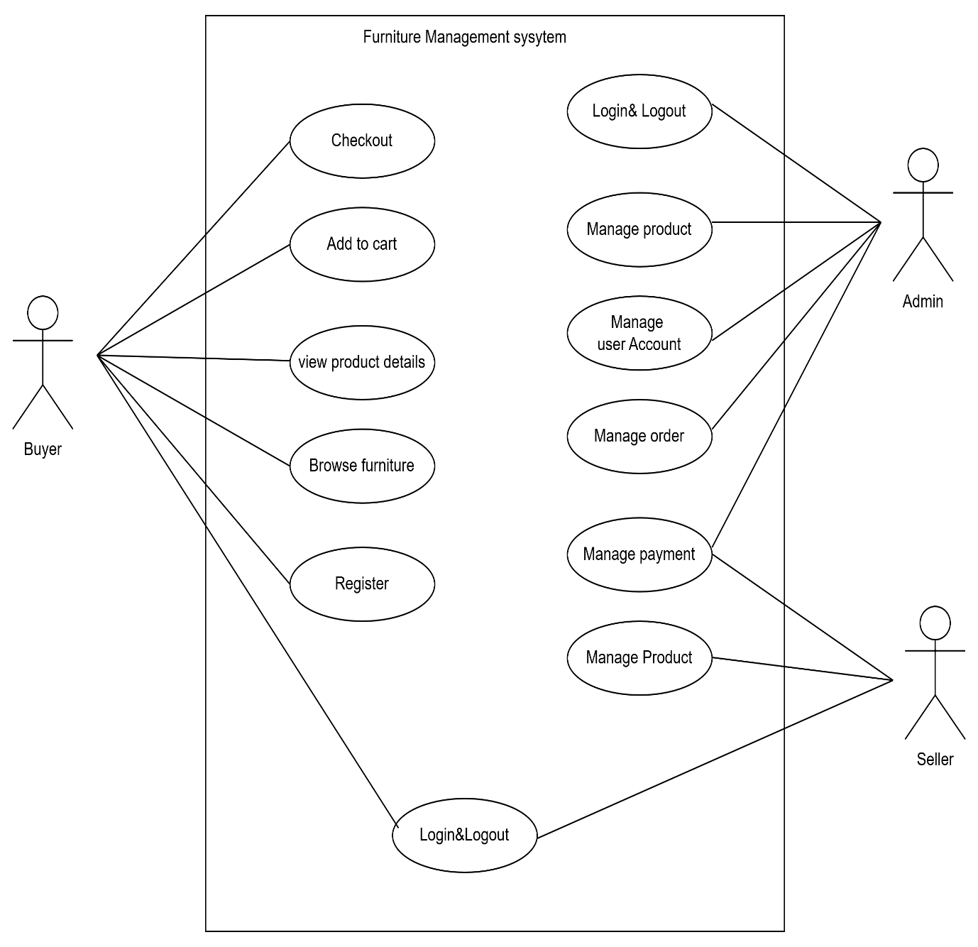Use case diagram